**WSUS clean-up task, Office 365 Updates option and synchronization, Multiple ADR deployment in SCCM**

WSUS enables IT administrators to **manage and distribute Microsoft product updates** across a corporate network. It ensures that all systems receive approved updates in a controlled and efficient manner.

**Core Features of WSUS**

* **Windows PowerShell Cmdlets:**  
  Allow scripting and automation of critical administrative tasks.
* **SHA-256 Support:**  
  Ensures **enhanced security** for update files via Secure Hash Algorithm (SHA-256).
* **Client-Server Separation:**  
  Versions of the **Windows Update Agent (WUA)** can be deployed **independently** from the WSUS infrastructure, offering more flexibility.

**WSUS Maintenance for Configuration Manager 1906 and Later**

**For Configuration Manager version 1906 or newer, enable WSUS Maintenance in the Software Update Point settings at the top-level site. This automates cleanup after each sync.**

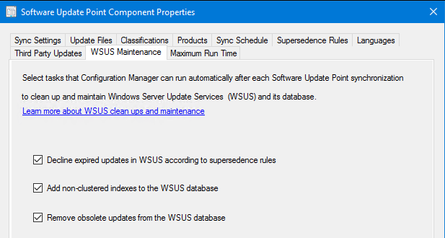

1. Read all instructions before starting WSUS maintenance.
2. Remove WSUS servers **bottom-up**, not top-down.
3. Start cleanup from **downstream servers** and move upward.
4. Maintain servers in the **same tier together**, but finish one tier before the next.
5. Run **cleanup and reindex** on **all WSUS servers**, including replicas.
6. **Pause SUP sync** during maintenance by setting it to manual.

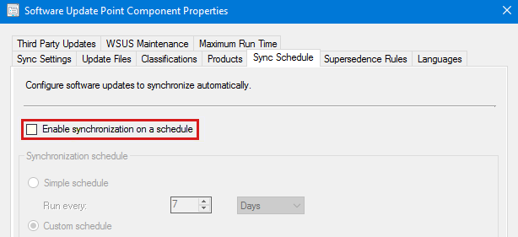

1. If multiple SUPs at a site don’t share the **SUSDB**, treat each WSUS server that syncs with another as being in a **lower tier**.

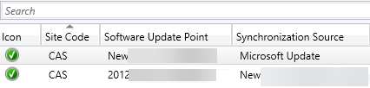

**Create Custom Indexes**

Creating **custom indexes** is optional but recommended, as it improves WSUS cleanup performance.

If you're using Configuration Manager **version 1906 or later**, enable **"Add non-clustered indexes to the WSUS database"** in the **Software Update Point settings** at the top-level site.

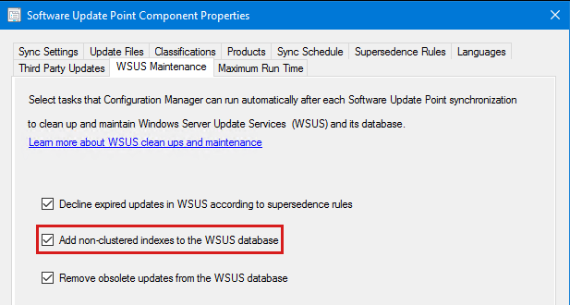

If you're using an older Configuration Manager version or standalone WSUS, you can manually create custom indexes in **SUSDB** to improve performance.

1. **Back up** the SUSDB database first.
2. Use **SQL Server Management Studio** to connect to SUSDB.
3. Run the provided script to create two custom indexes.

**Note:** If the indexes already exist, you'll get an error like:  
*"The operation failed because an index with name 'nclLocalizedPropertyID' already exists."*  
This just means the index is already in place and no action is needed.

**Reindex the WSUS Database (SUSDB)**

To reindex the **SUSDB**, run the **Reindex T-SQL script**.

Check the registry key at:  
HKEY_LOCAL_MACHINE\Software\Microsoft\Update Services\Server\Setup\SQLServerName

* If it shows just the **server name or instance**, SUSDB is on **SQL Server**.
* If it includes **##SSEE** or **##WID**, it's using **Windows Internal Database (WID)**.

Screenshot of SqlServerName-SSEE.

Screenshot of SqlServerName-WID.

**If SUSDB was installed on WID**

**If SUSDB was installed on WID, SQL Server Management Studio Express must be installed locally to run the reindex script.**

After installing SQL Server Management Studio Express, launch it, and enter the server name to connect to:

* If the OS is Windows Server 2012 or later versions, use \\.\pipe\MICROSOFT##WID\tsql\query.
* If the OS is older than Windows Server 2012, enter \\.\pipe\MSSQL$MICROSOFT##SSEE\sql\query.

For WID, if errors similar to the following occur when attempting to connect to SUSDB using SQL Server Management Studio (SSMS), try launching SSMS using the **Run as administrator** option.

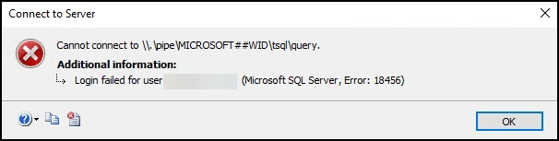

**Running the Script**

Open **SQL Server Management Studio**, select **New Query**, paste the script, and click **Execute**.

Once done, you’ll see **"Query executed successfully"** in the status bar, and the **Results pane** will show details of the reindexed items.

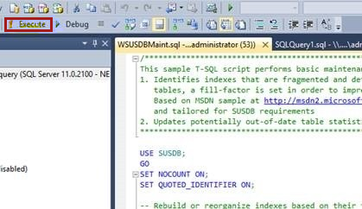

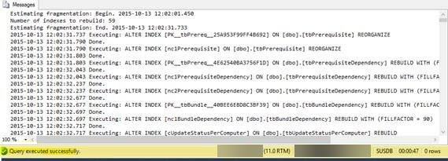

**Decline superseded updates**

**Decline superseded updates in the WSUS server to help clients scan more efficiently. Before declining updates, ensure that the superseding updates are deployed, and that superseded ones are no longer needed. Configuration Manager includes a separate cleanup, which allows it to expire superseded updates based on specified criteria. For more information, see the following articles:**

Supersedence rules

WSUS cleanup behavior starting in version 1810

The following SQL query can be run against the SUSDB database, to quickly determine the number of superseded updates. If the number of superseded updates is higher than 1500, it can cause various software update related issues on both the server and client sides.

**-- Find the number of superseded updates**

**Select COUNT(UpdateID) from vwMinimalUpdate where IsSuperseded=1 and Declined=0**

**Run the WSUS Server Cleanup Wizard**

**WSUS Server Cleanup Wizard provides options to clean up the following items:**

1. Unused updates and update revisions (also known as Obsolete updates)
2. Computers not contacting the server
3. Unneeded update files
4. Expired updates
5. Superseded updates

In Configuration Manager, the options **"Computers not contacting the server"** and **"Unneeded update files"** are usually not needed because ConfigMgr manages updates and devices. However, if you enable **WSUS reporting events** under Software Update Sync Settings, you should automate cleanup for those options.

If you're using version **1906 or later**, enable **"Decline expired updates"** and **"Remove obsolete updates"** in the Software Update Point settings. These options help clean up expired, superseded, and unused updates in the WSUS database automatically.

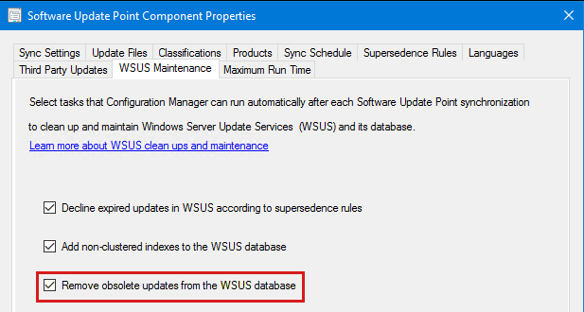

If WSUS cleanup has never been done, it may time out. Start by running the **"Unused updates and update revisions"**

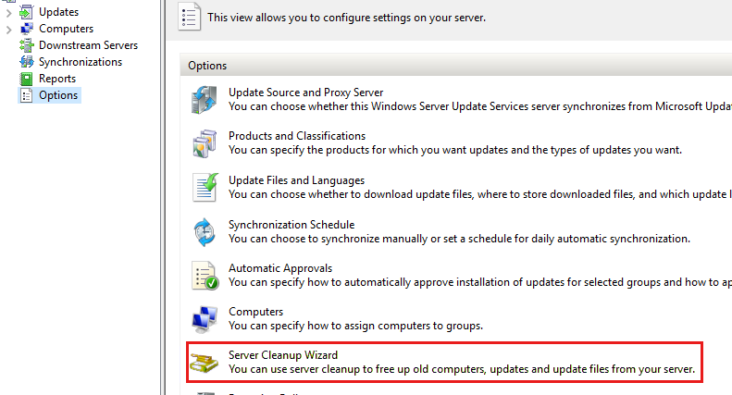

For more information, see Use the Server Cleanup Wizard.

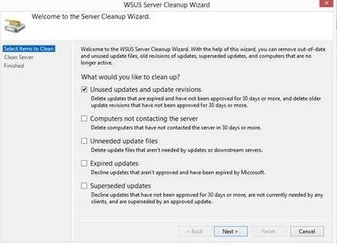

The WSUS cleanup is complete when it reports the number of items removed. If no summary appears, it likely **timed out** — run it again or use the **SQL alternative** method.

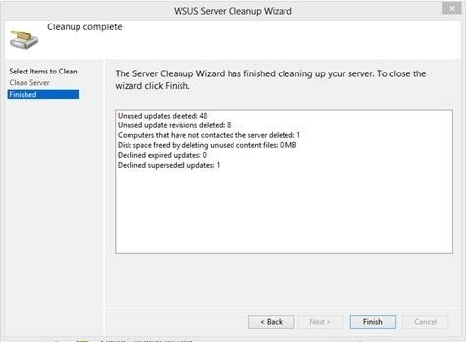

**Troubleshooting**

**HELP! My WSUS has been running for years without ever having maintenance done and the cleanup wizard keeps timing out**

**There are two different options here:**

1.Reinstall WSUS with a fresh database. There are a number of caveats related to this, including length of initial sync, and full client scans against SUSDB, versus differential scans.

2.Ensure you have a backup of the SUSDB database, then run a reindex. When that completes, run the following script in SQL Server Management Studio or SQL Server Management Studio Express. After it finishes, follow all of the above instructions for running maintenance. This last step is necessary because the spDeleteUpdate stored procedure only removes unused updates and update revisions.